**Computer Organization and Architecture (EET2211)**

**LAB I: Analyze the Arithmetic and Logical operations using different Addressing Modes of the 8086 Microprocessor.**

**Siksha ‘O’ Anusandhan (Deemed to be University), Bhubaneswar**

|  |  |  |  |
| --- | --- | --- | --- |
| **Branch: Section:** | | | |
| **S. No.** | **Name** | **Registration No.** | **Signature** |
|  |  |  |  |

**Marks: ______/10**

**Remarks:**

**Teacher’s Signature**

**I. OBJECTIVE:**

1. Perform Addition, Subtraction, Multiplication, and Division of two 16-bit numbers using immediate addressing mode and store the results using direct addressing mode.
2. Perform the following operations on two 8-bit data (**data1**, **data2**) given in memory locations and store the result in another memory location using indirect addressing mode.
   1. Swapping of nibble of **data1**
   2. $Y$ = (**data1** and **data2**) or (**data1** xor **data2**)
3. Find the Gray code of an 8-bit binary number.
4. Find the 2’s complement of an 8-bit number.

**II. PRE-LAB**

* Explain the addressing modes involved in instructions.

For each objective in prelab describe the following points:

* Write the assembly code with a description (ex. Mov ax,3000h – ax<-3000h)
* Examine and analyze the input/output of assembly code.

**III. LAB**

Note: For each objective do the following job and assessment:

* Screenshots of the Assembly language program (ALP)
* Observations (with screenshots)

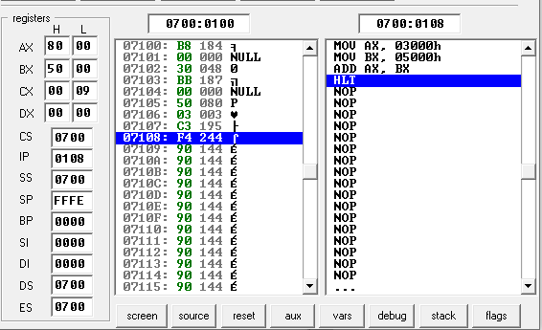

**Fig. 1.** Execution result of addition using immediate and direct addressing mode of 8086 emulator.

From this result, I have observed……

|  |  |
| --- | --- |
| **Input:** | **Output:** |
| |  |  |  | | --- | --- | --- | | **Sl. No.** | **Memory Location** | **Operand (Data)** | | **1** |  |  | | **2** |  |  | | **…** |  |  | | |  |  |  | | --- | --- | --- | | **Sl. No.** | **Memory Location** | **Operand (Data)** | | **1** |  |  | | **2** |  |  | | **…** |  |  | |

**IV. CONCLUSION**

**V. POST LAB**

1. Discuss different general-purpose registers used in 8086 microprocessors.
2. Explain the concept of segmented memory. What are its advantages?
3. Explain the physical address formation in 8086.
4. Write an assembly program to multiply 05H and 04H without using arithmetic instruction.
5. Write the function of the following logical instructions.

a) SHL/SAL b) SHR c) SAR d) ROR e) ROL